Greeting Ward, Price and Griffin Family!

We hope to find you well and in good health. We are excited about hosting the 2018 Family Reunion. Your Reunion Committee continues to work hard and are determined to make this year’s reunion the best it could be. So, you don’t want to miss it! We invite you to attend and participate in the 2018 Family Reunion in Windsor, CT. We have a fun- filled weekend planned for the entire family to enjoy. In this communication you will find the hotel, registration and itinerary information. Registration payment is all inclusive: meet and greet, picnic, banquet and t-shirt. There will be no separation of prices for each event.

Theme: “Our Roots Run Deep”
Dates: Thursday, August 2, 2018- Sunday, August 5, 2018
Location: Hartford/Windsor Marriott Airport, Windsor, CT
T-Shirt Colors: Lime Green and Purple
Registration Cost:
$90 (Adults 13 years and Older)
$70 (Children 4 years – 12 years)
Free (Infant – 3 years)

Early Bird Option due by 04/07/2018 ($5 off each person)
Final payment due Date: Saturday, June 2, 2018

Dolores (Peanut) Barber- President, (860) 678-9818, itsashaia@att.net
Crystal Knight- Vice President, (860) 461-3710, knightc6818@yahoo.com
Champayne Johnson- Treasure, (860) 997-5379, champaynejohnson@gmail.com
Phylicia Relph
Eddie Langford
Tanya Hite

For questions, you may reach out to one of the CT Family Reunion committee members. We thank you in advance for your participation. We look forward to seeing you soon.

The 2018 Connecticut Family Reunion Committee

Host Hotel- Hartford/Windsor Marriott Airport
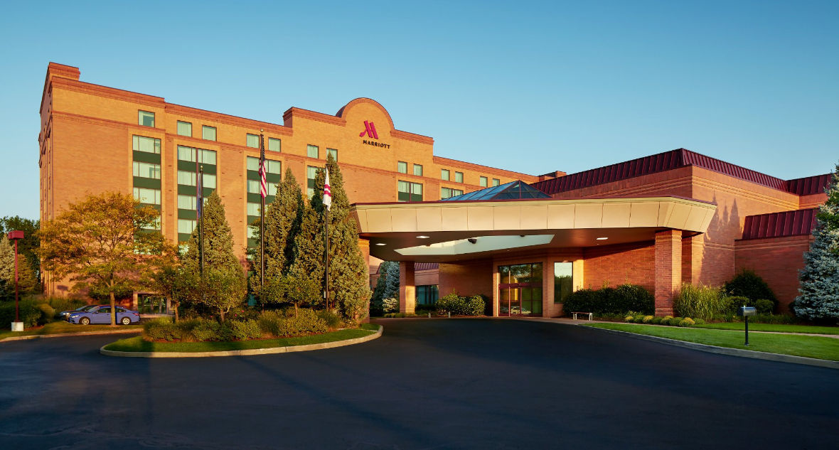
The Hartford/Windsor Marriott Airport hotel offers upscale newly renovated hotel accommodations and amenities, but it is our incredible location in Windsor, Connecticut that you will truly appreciate. We are just a short, complimentary shuttle ride from the Bradley International Airport and minutes from downtown Hartford. Our BDL Airport hotel is located near Cigna, Travelers, VOYA, Six Flags New England, the University of Hartford, and Rentschler Field, home of UConn Huskies Football. At the center of our hotel is the Marriott Great room; flexible seating and spaces with a contemporary style and design, a coffee bar proudly serving Starbucks® coffee, and a chef-crafted menu of small plates and pours. New Guest rooms feature ultra-comfortable bedding, 49-inch LED Smart TVs, and ergonomic work spaces.
Location: 28 Day Hill Road, Windsor, CT 06095
To Make Reservations: Call (860) 688-7500.
Website: http://www.marriott.com/hotels/travel/bdlap-hartford-windsor-marriott-airport
Group/Reservation Code: WPG2018. Rates are valid through 07/19/2018. Space is limited.
Nearest Airport: Bradley International Airport, Windsor Locks, CT 06096
Hotel Parking: No Charge for guests

1 | Double, Queen or King | $99 per night plus tax per night
2 | Double, Queen or King with breakfast included up to 4 guests in a room | $124 per night plus tax per night
3 | Suite | $249 per night plus tax per night
4 | Suite with breakfast included up to 4 guests in a room | $274 per night plus tax per night
* Hotel room rates are subject to applicable state and local taxes (currently 15%) in effect at the time. *

Reunion Itinerary
Thursday, August 2, 2018
- 3:00 pm, Hotel Check-in
- Pick up registration packets from 12 pm- 4:30 pm, then from 5:30 pm onward
at meet and greet location
- 6:00 pm- 9:00 pm, Meet and Greet
  - Theme: Sports Game Night, Windsor Marriott
  - Wear your favorite sports themed paraphernalia
For example: UConn Huskies t-shirts, Yankee hat, Steelers socks, etc.
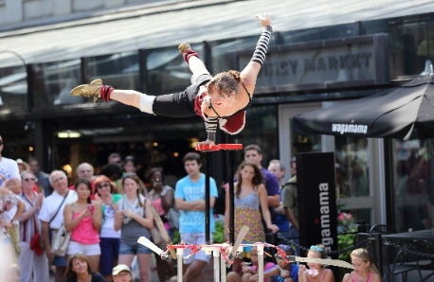
  - Light refreshments will be served
Friday, August 3, 2018
          - 8:00 am- 4:30 pm, depart hotel at 8:00 am
            - Day trip- Quincy Market, Boston, Massachusetts
            - Shopping, site seeing, museums, Boston Aquarium, dinning
            - A bus is being donated by a family member for the day trip to Boston. Seats will be first come, first serve basis for paid registrants.
            - https://www.faneuilhallmarketplace.com/
            - https://www.boston-discovery-guide.com/quincy-market.html
          - 7:00 pm- 12 am, Banquet
            - Theme: Hawaiian Night Banquet, Windsor, Marriott
            - Come dressed in your Hawaiian attire
            - Buffet Dinner, Music, dancing and fun
Saturday, August 4, 2018
- 1:00pm- 8:00 pm, Picnic
  - Nevers Park, South Windsor, CT
  - Wear reunion T-shirt (colors: lime green and purple)
  - Food, Fun, games, art and crafts (adults and children are encouraged to participate)
  - Playground for children, volleyball, baseball and basketball games
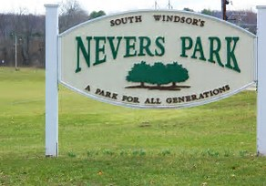
  - Parking available near pavilion area

Sunday, August 5, 2018
- 10:00 am, Church Service
  - Morning Worship: Sanctuary, Faith and Glory Church
- Address: 752 Bloomfield Ave, Windsor, CT 06095
2018 Connecticut Family Reunion Registration Form
Registration payment is all inclusive: meet/greet, banquet, picnic and t-shirt. All of the following information is required for all registrants including infants: first and last name, age (at time of reunion), date of birth and t-shirt size. The name, address and phone are required for the main registered person. Please print clearly and return form with payment.
Registrant Name: ____________________ ______ Phone Number: ___________________________
Registrant Address: ____________________________________________________________________________
Email Address: ________________________________________________________________________________
 | First Name |  | Last Name |  | Age  (Time of Reunion) | Birth Date |  | T-Shirt Size | Total
Ex. | Mickey |  | Mouse |  | 37 | 02/02/1980 |  | A1X | $90.00
1
2
3
4
5
6
 |  |  | EX: Example on the first line on how to fill out the registration form. |  |  | Early Bird: Receive $5 off each person if payment received by 04/07/2018 person. (Full payment must be received in order of apply the early bird option. No partial payment with this option.) |  | Total:
T-Shirt Size Chart |  | Youth | Adult | Age Range |  | Cost
Small |  | Small | Small | 13 years of age- Adult |  | $90.00
Medium |  | Medium | Med. | 4 years of age- 12 years of age |  | $70.00
Large |  | Large | Large | Infants- 3 years of age |  | Free
 |  |  | 1X
 |  |  | 2X
 |  |  | 3X
 |  |  | 4X
 |  |  | 5X

Partial payments are accepted until registration is paid in full. Partial payment amount: _________________
All Final Payments Due By 06/02/2018

Make checks/money orders (US Postal money orders are preferred) payable and mailed to:
Champayne Johnson, 66 Midian Avenue, Windsor, CT 06095.

